M71HV INSTRUCTION

1.BRIEF INSTRODUCTION
Brief Introduction
M71Hv is a high-performance and highly scalable product developed specifically for emergency/temporary video surveillance and remote video surveillance. The product adopts integrated design, integrating audio and video hardware encoding, 5G/4G network, GPS&BeiDou, data storage, lithium battery and other modules. It can be combined with camera devices such as drones and DV cameras through the HDMI input interface. It has the characteristics of lightweight and compact, flexible and convenient use, comprehensive functions, and high reliability. Suitable for mobile monitoring fields such as electricity, law enforcement, road administration, and field photography.
Product Advantages
- IP65 protection level, suitable for various complex environments
- Video encoding H.265 and H.264 are optional
- Supporting 5G, 4G, WIFI, and GPS function modules
- Supports one MicroSD (TF) card storage
- Built-in lithium battery can work continuously for 12 hours
- Equipped with anti glare status display screen
- Equipped with USB, HDMI and other interfaces
- High scalability

2.KEYS AND INTERFACES
Top Structure
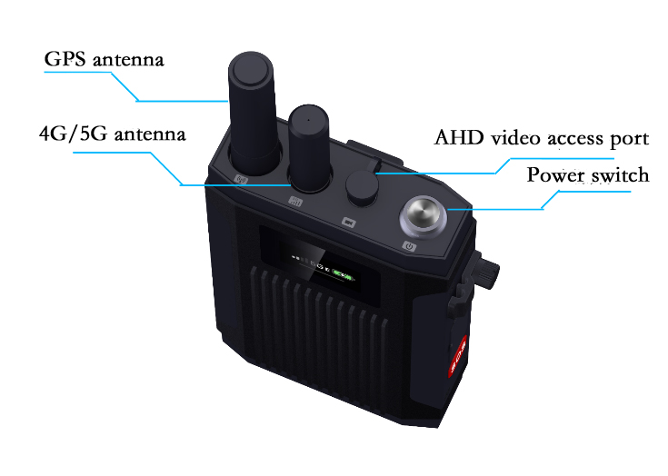
Side Structure
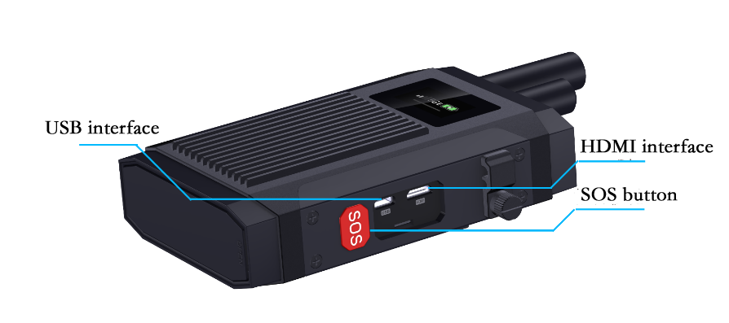

Bottom structure
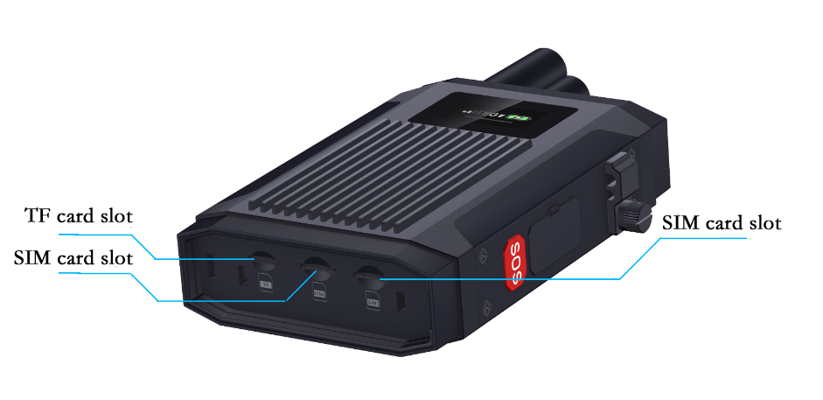

3.INSTRUCTION MANUAL
(1).Key Description
Power On Button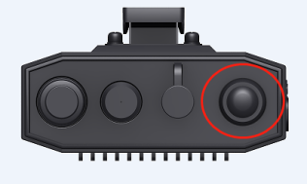 | Operation | Instruction
 | Press three seconds | on/off
 | Short press | Wake up the screensaver, display device ID, and center IP information
 | Continuously short press twice | Switch voice mode, intercom/PTT
 | Short press three times | Turn Bluetooth function on/off
 | Short press four times | bluetooth pairing
 | press for more than 6 seconds | Forced shutdown, used in case of abnormal crash
SOS Button  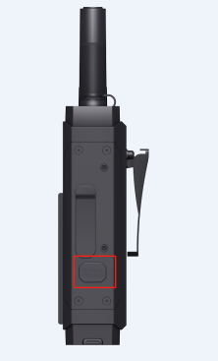 | Short press 1 or 2 times | Alarm recording
 | Short press three times in a row | The general version is invalid. The video channel of the Zhuozhida docking version is AHD/HDMI, and it takes effect after restarting
 | Short press four times in a row | Switch HDMI input resolution, 1080P/720P, restart takes effect
 | Long press | Trigger platform emergency alarm, release and end the alarm

(2).Instructions For Platform Operation
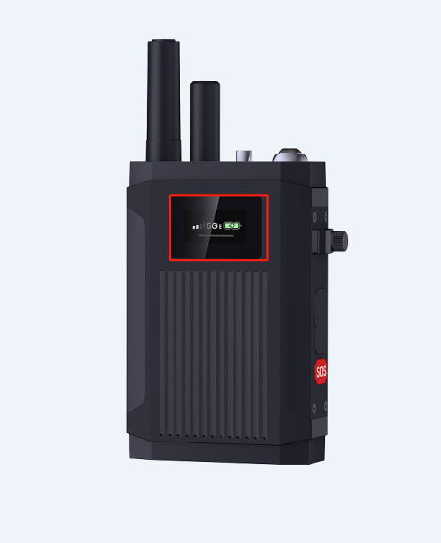
Status display screen
Long press and hold for three seconds to turn on the device. When the WiFi icon on the display screen shows AP mode, open the phone's WiFi and connect to the "MDVR1234567" WiFi with a password of "99999999". After successful connection, the phone's browser accesses the IP address "192.168.42.100". Enter the web login interface with the default password of "Adm_123". Enter the password, and after successful login, click on the setup wizard to configure the platform parameters. If you need to configure WiFi to go online, you need to manually enter the SSID and password. After configuration is completed, you need to disconnect the device's AP from the phone, otherwise the device will remain in AP mode. After disconnection, the AP mode will switch to WiFi and automatically connect to go online; If 4/5G goes online, you don't need to configure WiFi, just go to the next step until it is completed.
(3).Other Operating Instructions
Connect Bluetooth/intercom: Push up the power button on the left side of the Bluetooth earphone to turn it on. After turning it on, it will automatically enter pairing mode. Then, briefly press the host power button four times to enter pairing mode. When the Bluetooth earphone announces that "Bluetooth is connected" and the Bluetooth icon on the host screen changes to , Bluetooth is connected to the host. Press the top of the Bluetooth front to initiate/end intercom.

4.STATUS DISPLAY
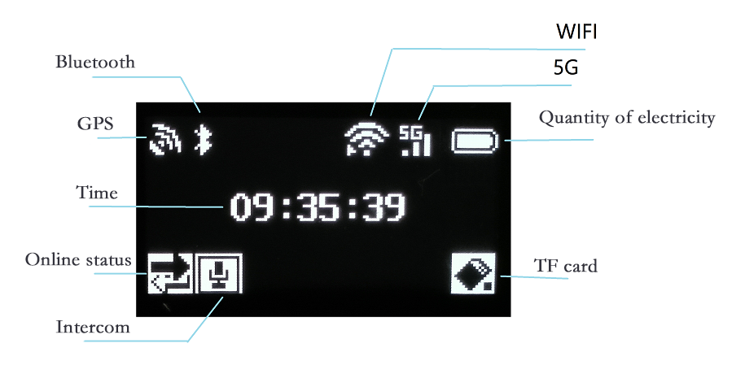
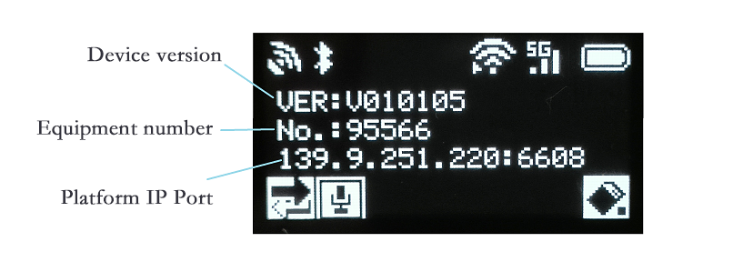

Icon | Brief Introduction | Remarks
Bluetooth | Press the power button three times continuously to turn Bluetooth on/off. A Bluetooth icon indicates that Bluetooth is turned on | Indicates Bluetooth is connected, indicates Bluetooth is not connected
GPS | The figure indicates successful positioning, and the flashing GPS signal indicates that positioning is in progress
Time | After successful device positioning, automatically calibrate the time | Time can also be manually calibrated through the platform
Online icon | As shown in the figure, the device has been launched, but the icon will not be displayed if it has not been launched
Intercom | As shown in the figure, the device is talking to each other, and the icon will not be displayed if there is no intercom | Continuously short press the power button to switch between intercom/PTT
WiFi | Indicates successful WiFi connection, indicates WiFi not connected | Indicates AP mode, where the device will continue to power on for one minute and then switch to WiFi mode
5G | As shown in the figure, 5G dialing was successful, while other states indicate unsuccessful dialing | There are four signals in total, and the more signals, the stronger the signal
Electricity | Display the current battery level of the device. When the battery level is low for charging, a "+" will be displayed in the battery icon, indicating that charging is in progress
TF | The picture shows that there is a card and it is in the recording state | No TF card inserted/No TF card read

5.SET ACCESSORIES

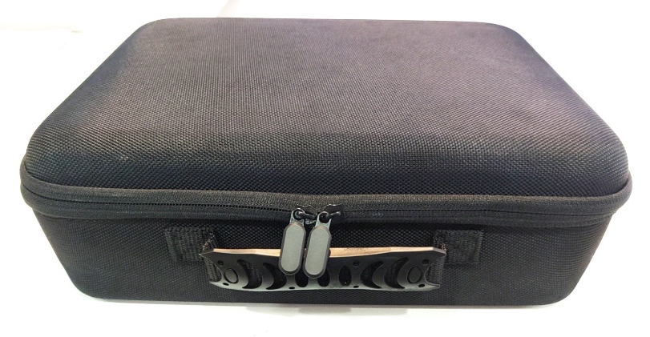
Storage box (size 350mm * 270mm * 250mm)

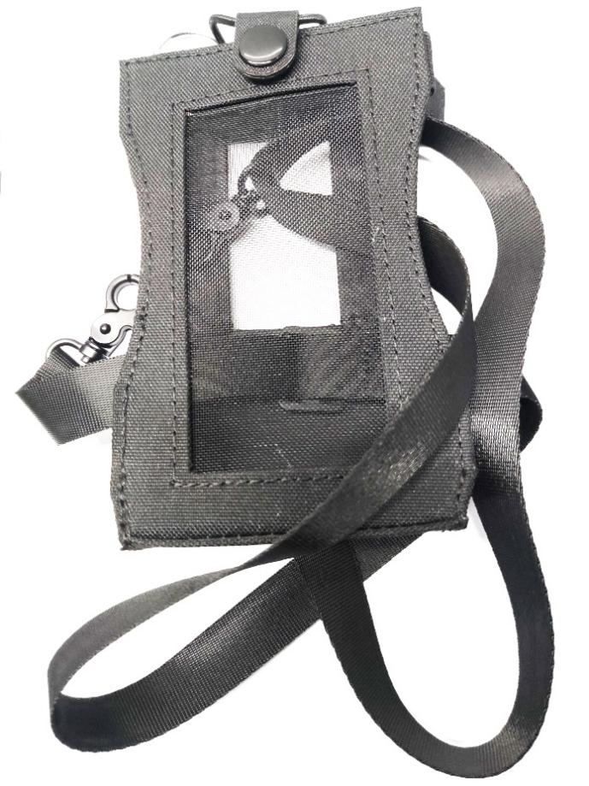
Portable waist pack (for loading and carrying the host)
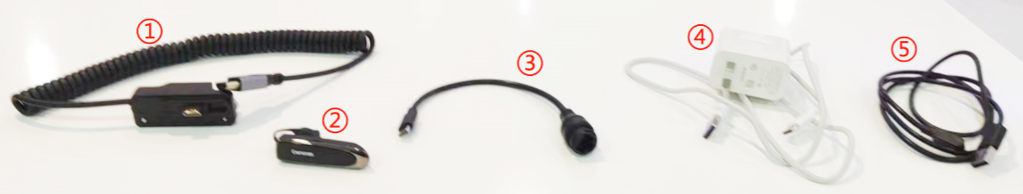
From left to right:
- HDMI video access cable
- Bluetooth earphones
- RJ45 network port adapter cable
- TYPE-C charging package
- Magnetic suction charging module

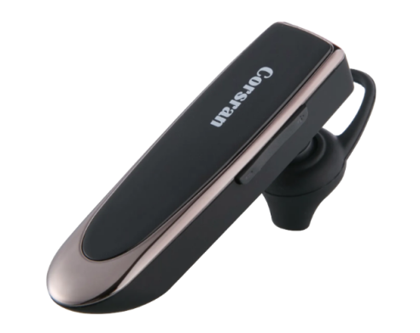
Bluetooth earphones (standard)
Main Specifications
①Bluetooth version
②Charging time: 2 hours
③Transmission distance: 10M
④ Working temperature: -10 °~60 ° C

Key | Brief | Marks
+/- | Volume control button | Control Bluetooth volume
ON/OFF | Switch button | Turn on or off the Bluetooth earphone power
Top slot | charge hole | For charging earphone
Inform
This device is a precision instrument and equipment. Please strictly follow the user manual for operation. Unplanned operations, such as using a non matching charger to charge the device, may shorten the service life of the device, or even cause short circuits or damage;

The instruction document was officially released in August 2023, Version 1.01. There are multiple customized versions of this device. If there are any discrepancies between the functionality of your device and the content of the manual, please refer to the information provided by the staff for your reference;

